**Mouth Travelers**

* **Home page**

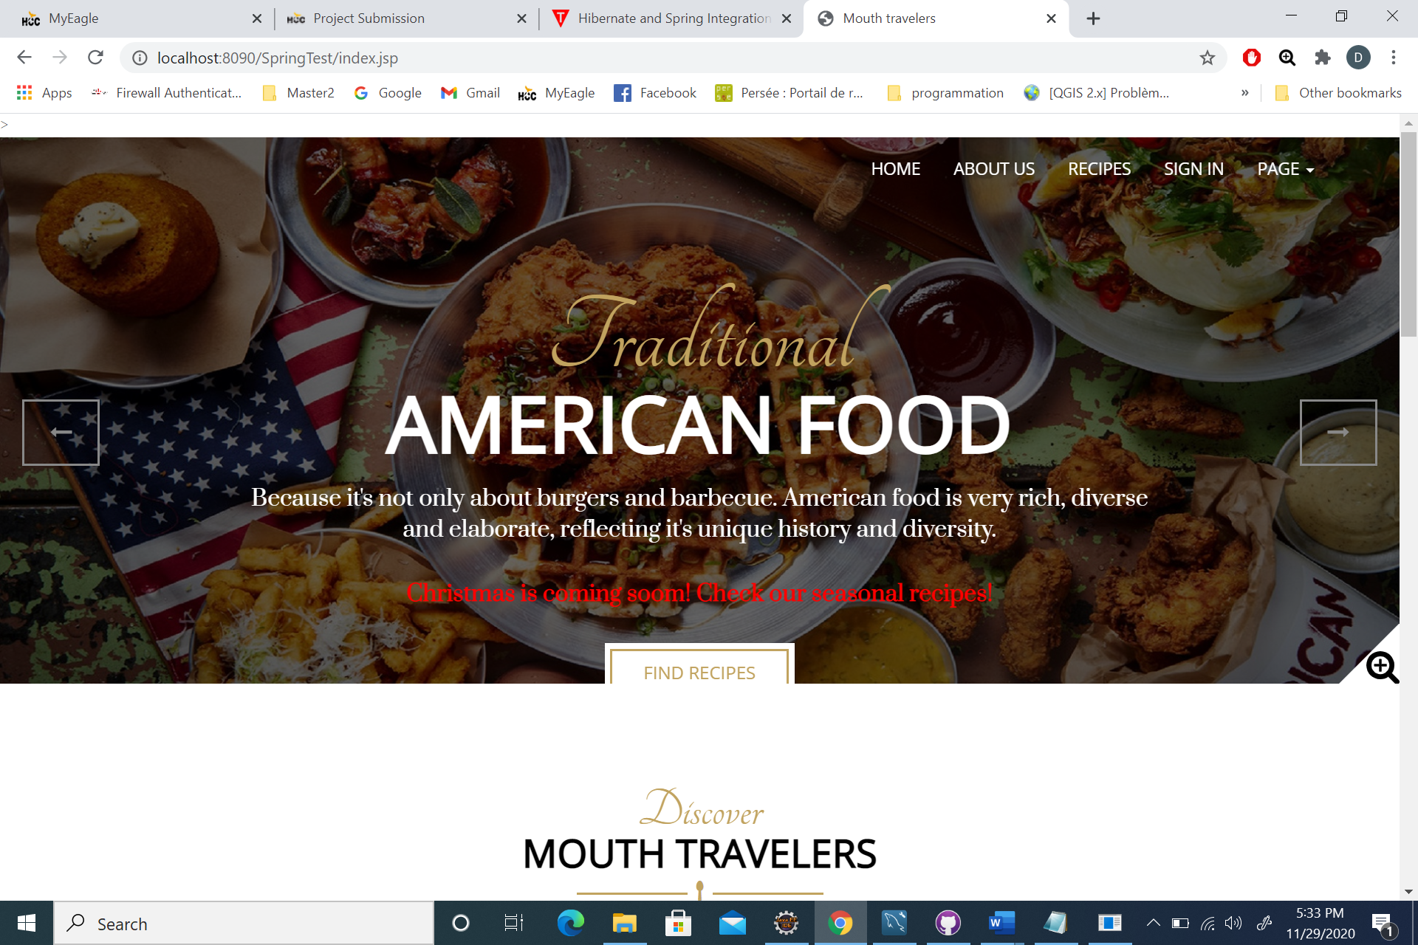

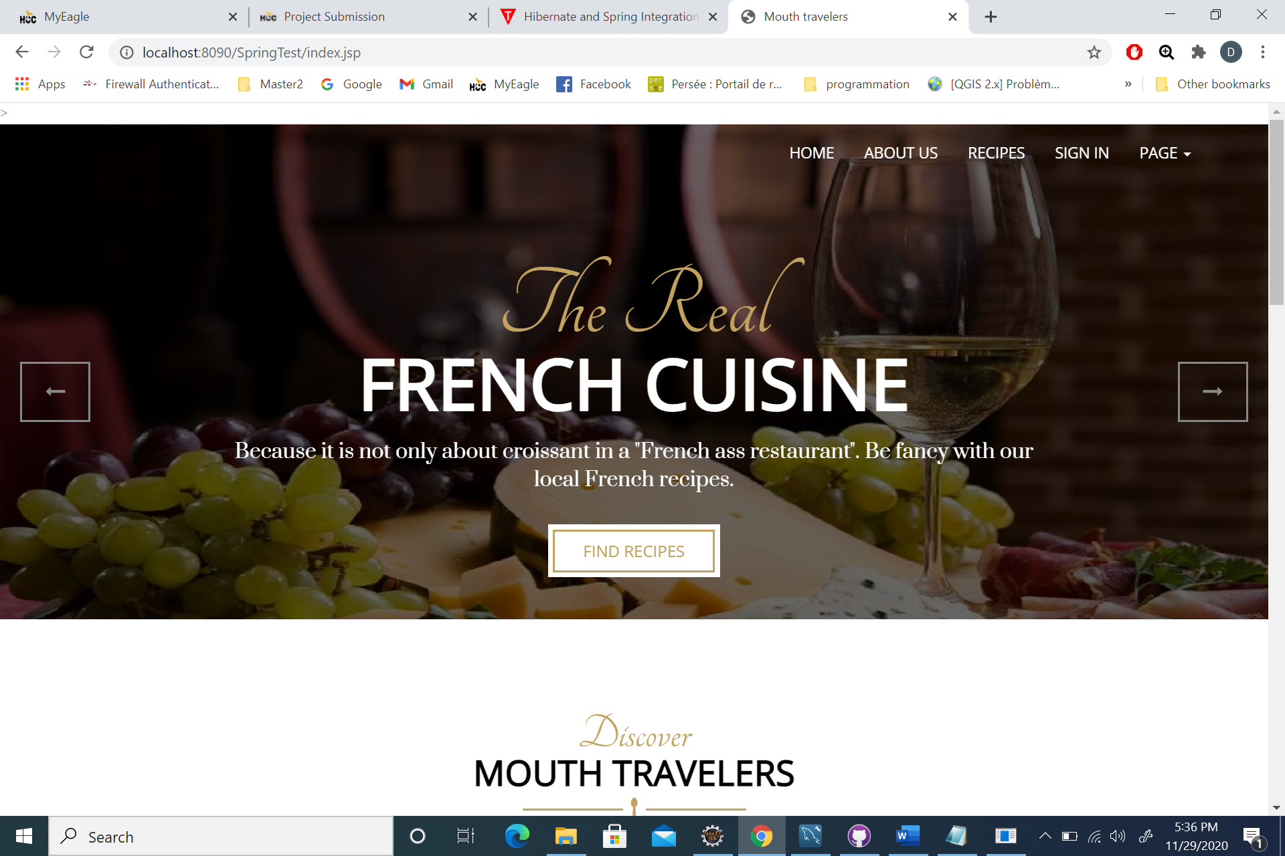

Top sliders are automatically changing. “Find recipe” buttons redirect the user to the recipe page.

* **Recipe page**

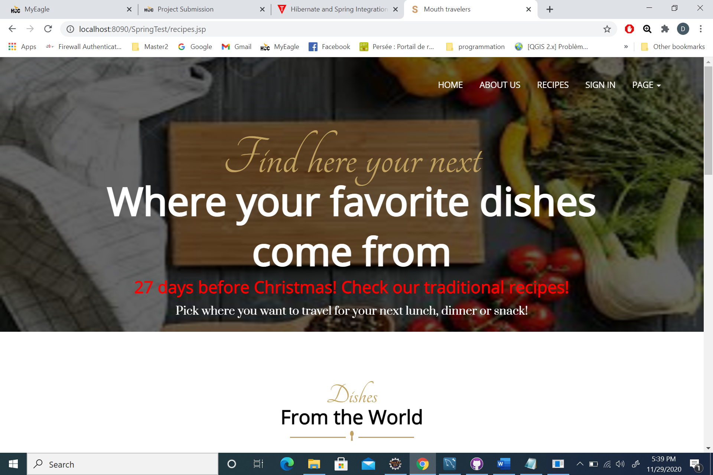

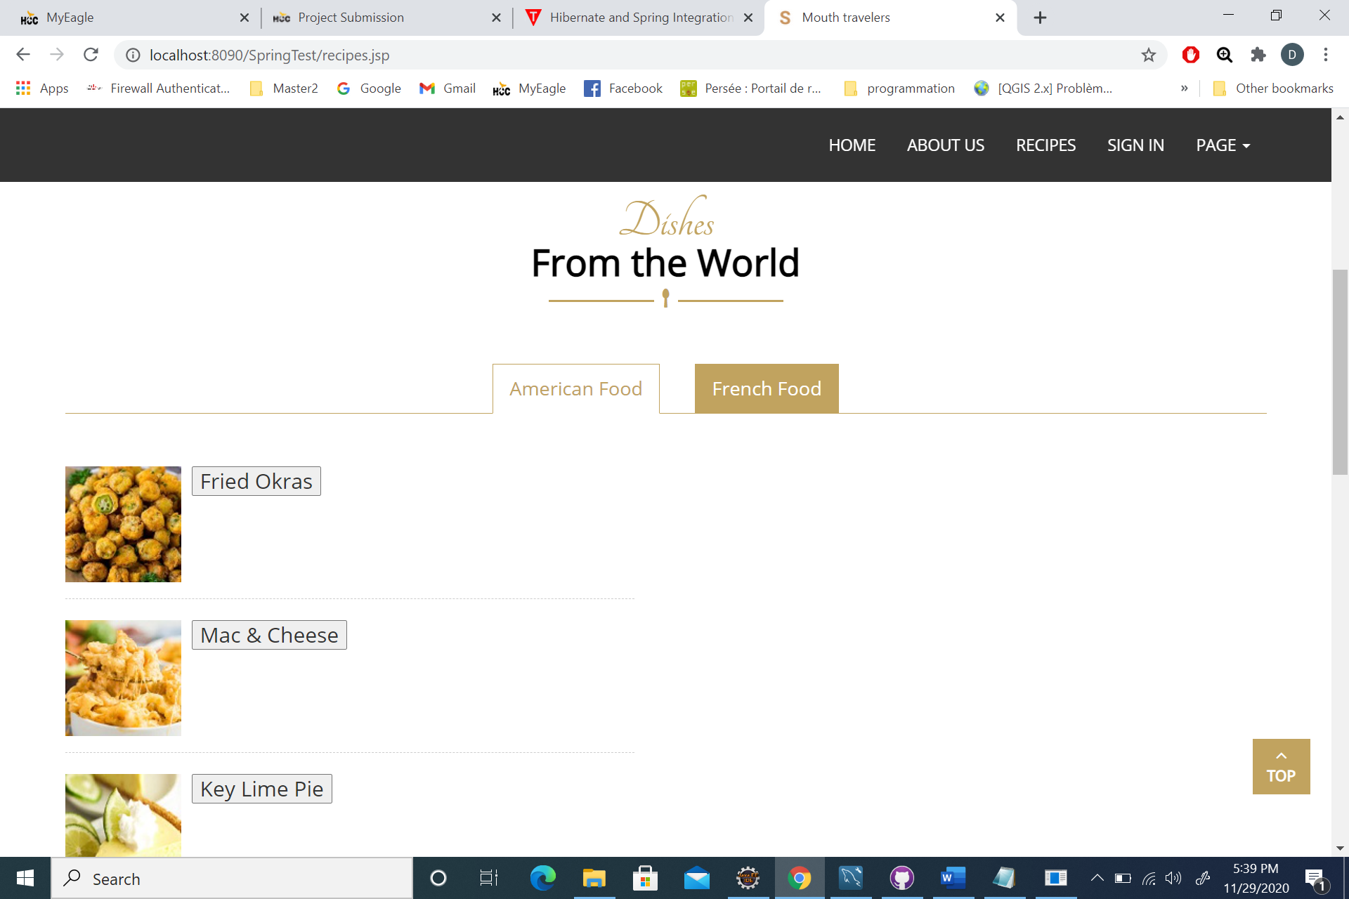

Users can choose among American recipes in the “American Food” tab or French recipes in the “French Food” tab.

Once they click on a recipe, the description, recipe, video tutorial, etc. appear below, on the same recipe page.

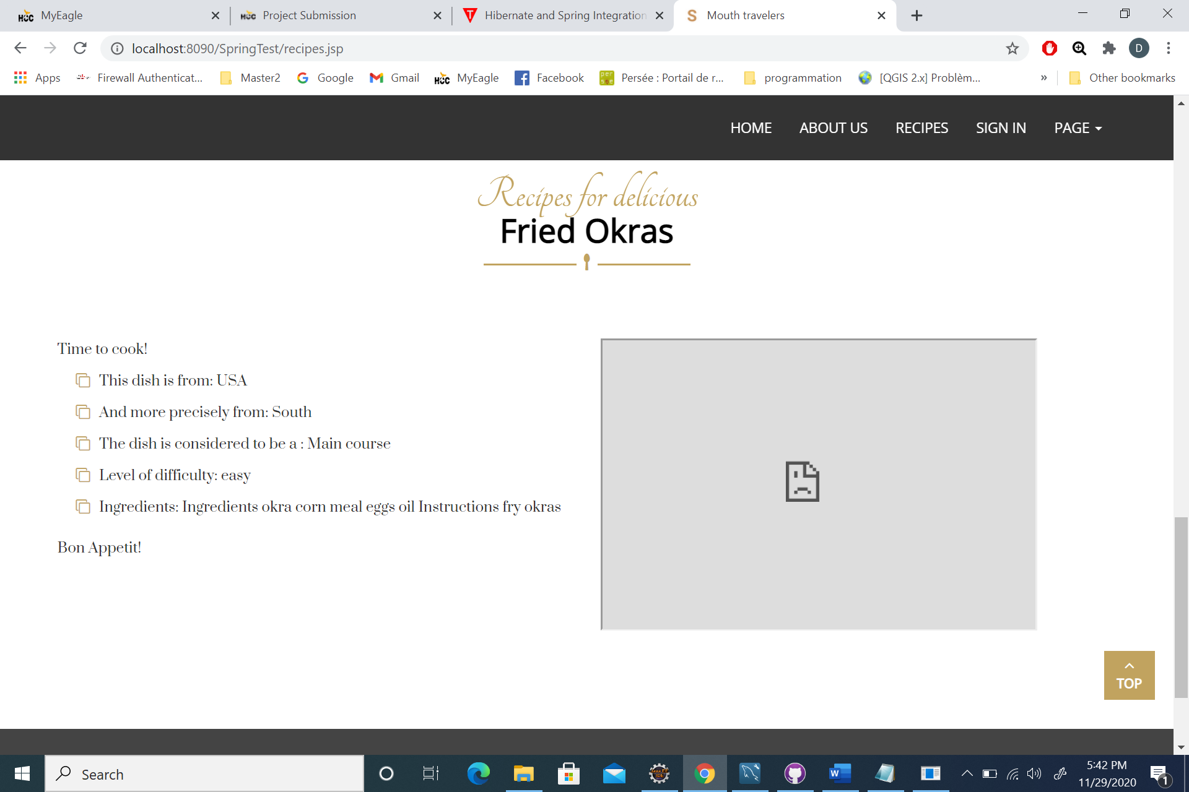

As mentioned in the readme document, I am having some issue with the youtube opening.

* **About us**

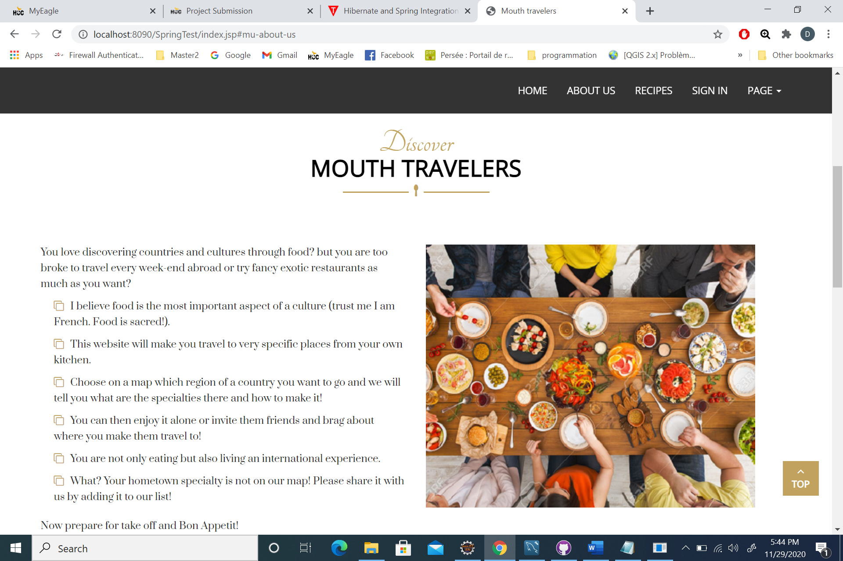

The rubric is on the home page. Clicking “about us” redirect the users to this particular section of the page.

* **Sign in**

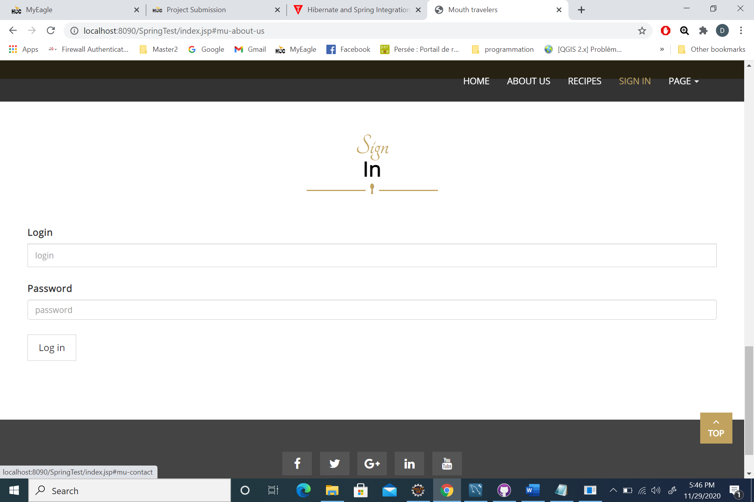

The only account created is Diane (login) and 1234 (password) for the moment.

Once logged in:

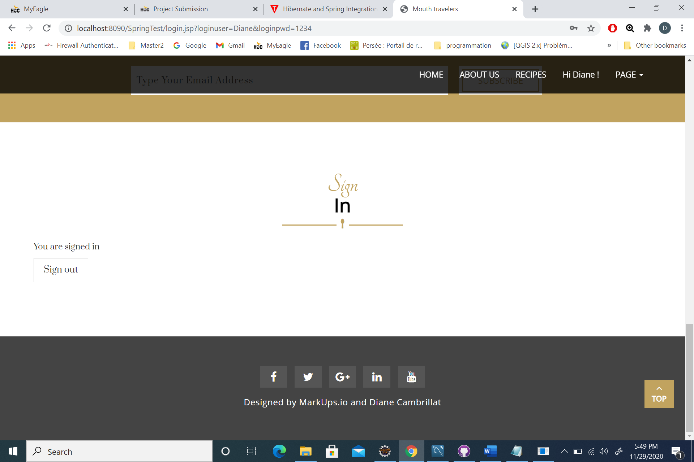

* **PAGE link**

I haven’t been working on these other pages for the moment. But we can imagine a “create an account” page or a “view recipe map” page for the future.